## Self-Directed Learning Tools in USAF Cyber Education and Training

Nathaniel Flack, Mark Reith

Department of Electrical & Computer Engineering, Air Force Institute of Technology, Dayton, USA

[nathaniel.flack@afit.edu](mailto:nathaniel.flack@afit.edu)

[mark.reith@afit.edu](mailto:mark.reith@afit.edu)

**Disclaimer:** The views expressed are those of the authors and do not necessarily reflect the official policy or position of the Air Force, the Department of Defense, or the U.S. Government.

**Abstract:** The United States Air Force is currently conducting a complete overhaul of its education and training paradigm, shifting from multi-month face-to-face programs to a modular, agile, on-demand design. This new initiative, called the Continuum of Learning, plans to leverage advanced learning and education tools to create and sustain life-long learners in the Air Force. This is a lofty goal that can only be obtained by developing systems that leverage both people and technology to promote Self-Directed Learning, a term coined by Malcolm Knowles in the 1960s. This paper describes the concept of Self-Directed Learning and explains its effectiveness in building and fueling life-long learners who can adapt to new situations and meet new challenges. It examines the components of information technology tools that contribute to a user’s development as a Self-Directed Learner and encourages them to reach new goals. Specifically, tools must be human-centered, intuitive, open, dynamic, and encourage collaboration. One emerging solution that contains basic forms of these elements is the Cyber Education Hub™. This cloud-based learning tool is designed to present crowd-sourced content on an intuitive platform that encourages community engagement and feedback providing cyber education to a broad spectrum of personnel in the armed forces. While this system addresses the unique challenges of cyber education and training, it has the potential to inform the design of future Continuum of Learning systems covering many functional areas. The paper proposes the Cyber Education Hub™ add a user launch page to provide more customization and another avenue for collaboration. The paper concludes by offering a construct for a human subject research experiment to test the effectiveness of the new element.

**Keywords:** US Air Force education and training, Continuum of Learning (CoL), Self-Directed Learning (SDL), cyber education, Cyber Education Hub™ (CEH™), Heutagogy

**1. Introduction**

The US Air Force (USAF) is currently conducting a complete overhaul of its education and training paradigm, shifting from multi-month face-to-face programs to a more modular, agile, and on-demand design. This new initiative plans to leverage advanced learning and education tools with the overall goal of creating and sustaining life-long learners in the USAF.

Many have called for changes to military education and training strategies. The Secretary of Defense, James Mattis, is one of these voices. He emphasized that the US Armed Forces need to “be prepared to deal with technological, operational, and tactical surprise, which requires changes to the way we train and educate our leaders and our forces…” (Mattis, 2017).

Air Education and Training Command (AETC), the USAF Major Command dedicated to recruiting, training, and educating the USAF, is responding to these calls by transforming the way they think about education and training and forging new information technology tools to support that transformation. Roberson and Stafford (2017) describe the new philosophy on education and training as the Continuum of Learning (CoL) supported by an online Learning Ecosystem. AETC, through this new construct, wants to move learning from the classroom to where it is needed right now. This means a shift away from instructor-led learning to self-learning and online courses.

According to AETC’s leadership, the overall goal of these efforts is to create learning effectiveness by creating and supporting life-long learning. Figure 1 shows the concept of the Learning Ecosystem explained by Lt Gen Roberson and Dr. Stafford in their description of the CoL.

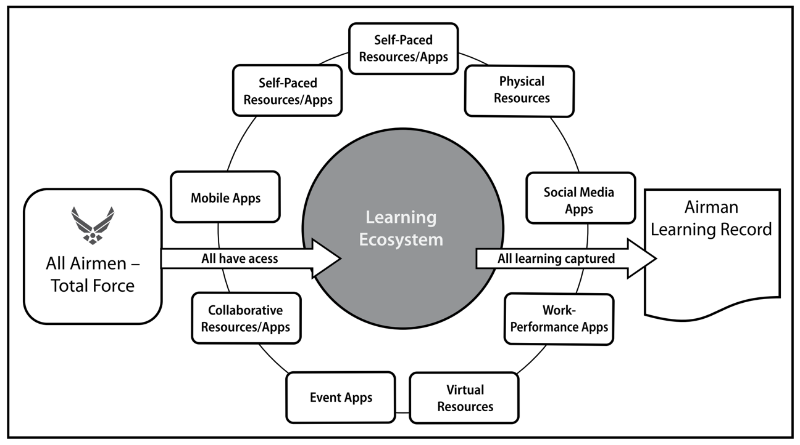

**Figure 1.** The USAF Learning Ecosystem pictured by Roberson and Stafford (2017).

The CoL will change the way the USAF approaches education and training by providing modularized, blended, competency-based learning that can be either mandated by a training authority or accessed by the learner “on-demand”. Furthermore, the Learning Ecosystem will track an individual’s learning experiences serving as the centralized record of what an Airmen knows and what he or she can do. More information and explanation are provided in Roberson and Stafford (2017).

The USAF is not alone in making significant changes to their education and training mindset. The US Army is also making changes with a similar goal. The US Army Learning Concept for Training and Education for 2020-2040, as quoted by Roberson and Stafford (2017), focuses on building a “learner-centric approach that creates life-long learners through the use of technologically enhanced training, top-notch instructors and outcomes-focused curricula—all delivered using a variety of mutually supportive modalities.” Leveraging modern technology both the US Army and USAF are transforming their education and training seeking to create life-long learners.

Developing life-long learners is a lofty goal and requires research concerning the definition of a life-long learner and how an organization, like the military, can encourage members toward life-long learning. A simple definition of a life-long learner is someone who continues to learn throughout, not just at the beginning, of their lifetime. The term implies that one rarely arrives at a point where they know everything about a certain topic but can continuously add to their understanding. The life-long learner desires to reach beyond what they currently understand to explore the unknown. This notion is captured in the term Self-Directed Learning (SDL), made popular by Malcolm Knowles in the 1960s.

**2. Self-Directed Learning**

Knowles (1975) defines SDL as the practice of studying a subject without the explicit guidance of formalized education and training. Knowles focused his research and writing on andragogy, a term first used in the 1830s to refer to the study of the education of adults. He differentiated this from pedagogy, the study of educating children, by focusing on the self-direction in adults.

Knowles shifts the responsibility for learning from the teacher to the learner, “Individuals take the initiative, with or without the help of others, in diagnosing their learning needs, formulating learning goals, identifying human and material resources for learning, choosing and implementing learning strategies and evaluating learning outcomes” (As quoted in Hase and Kenyon, 2000).

Although Knowles distinction between how adults and children learn is important, current scholarship has shown that this needs to be taken to another level to draw out the full implications of SDL. Hase and Kenyon (2000) hold that this next step is a revolution applicable across the whole spectrum of the education and learning lifespan. This revolution takes into account the interconnected and rapidly changing world human inhabit in the 21st Century. They write, “[a world in which] change is so rapid that traditional methods of training and education are totally inadequate…modern organizational structures require flexible learning practices; and there is a need for immediacy of learning” (Hase and Kenyon, 2000).

In response to all of these various challenges, they propose a new term, *Heutagogy*, to help go beyond adult learning to true SDL. They define Heutagogy as the study of self-determined learning that emphasizes the holistic development of independent learning in the individual. Figure 2 shows four stages of SDL that guide the learner.

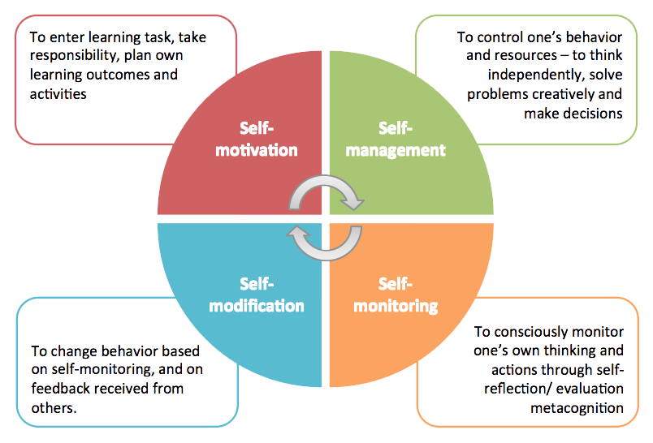

**Figure 2.** The SDL cycle cited from [http//cte.smu.edu.sg/learning-resources/self-directed-learning](https://cte.smu.edu.sg/learning-resources/self-directed-learning)

Hace and Kenyon (2000) envisioned their framework meeting future needs in a constantly changing world. “Heutagogy looks to the future in which knowing *how to learn* will be a fundamental skill given the pace of innovation and the changing structure of communities and workplaces.” Since that time the World Wide Web, social media, and near instantaneous information sharing have forged the “Web 2.0” and fundamentally changed the environments learners live and work in, just as they predicted. ﻿“With its learner-centered design, Web 2.0 offers an environment that supports a heutagogical approach, most importantly by supporting development of learner-generated content and learner self-directedness in information discovery and in defining the learning path” (Blaschke, 2012). These changes are a significant factor in driving the current education and training shifts. However, while technological advancement in electronics and communication have created challenges in current education models, technology can effectively deliver education and training on a grand scale. Specifically, recent innovations have created effective electronic applications and tools for SDL.

**3. Information Technology and Personal Learning Environments:**

While many SDL tools exist, both physical and electronic, the adaptability and connectedness enabled by the Internet has provided a huge boost to the viability of SDL for large audiences. In the discussion of SDL tools, one category of tools has emerged that is most centered on the learner. These tools are called Personal Learning Environments (PLE). PLEs store and link information in a format and arrangement that best fits the learner’s preferences.

Examples of generic PLEs:

* Google or Microsoft Online Accounts
* Blogs
* Microblogging (Twitter.com, Tumblr.com)
* Resource and image sharing sites (Instagram.com, Pinterest.com, Flickr.com, etc.)
* Wiki (a website that allows collaborative editing, i.e. Wikipedia)
* Personal website
* Cloud storage account (Apple iCloud, Dropbox, Microsoft OneDrive, etc.)
* Social bookmarking site (Facebook.com, Pinterest.com, Reddit.com, etc.)

Attwell (2007) provides a thorough overview of PLEs and explains how they effectively support life-long learning. Hayworth (2016) outlines four key traits of effective PLEs:

(1) Easy to use. The tool must be intuitive or very easy to learn. This requires the user (learner) to be at the center of development.

(2) Open. It must be able to extend and expand as relevant capabilities and plug-ins are desired.

(3) Dynamic. The tool must continuously adapt and grow as new requirements are defined.

(4) Provide collaborative options. The collaboration aspect of PLE’s provide powerful capabilities to connect SDLs in order to further research and create new connections.

Since 2007, research and development of SDL tools and web-based PLEs have progressed making them ripe for inclusion in the military education and training context, especially in the USAF during the transition to the CoL framework.

**4. SDL in Military Education and Training**

The military is facing the same challenges as the wider world stemming from digital transformation and interconnectivity which complicates military communities, work centers, and battlefields. The application of the principles of heutagogy and the encouragement toward SDL should be a key consideration in growing a military force ready to operate in a 21st century environment. However, there are several aspects of SDL that will require evaluation and testing before implementation in the military.

One issue is that the needs of the military will almost always overshadow the goals of the learner. This is identified by Hiemstra (2011) who discusses the balance of learners’ goals with institutional goals. He writes, “in terms of university teaching, obviously some learning goals need to be set by an instructor or are established by standardized curricular decisions; however, decision-making by adults toward their own specific learning needs should be the goal.” This point addresses the university context, however the same is true for the military context. Commanders, managers, trainers, and instructors will need to play a significant role in identifying student (warfighter) goals so that military organizations at all levels are prepared to accomplish the mission. This is a clear need when the operational competencies are known, and the goal of the training is to reproduce proven outcomes.

America is very proficient at training warfighters to succeed in operational contexts that are well-known and relatively predictable. Through repetition and discipline, military members are taught how to fight according to well-established tactics, techniques, and procedures. The military should not discard this training and discipline but should emphasize it throughout a warfighter’s training. In this context, SDL models will seem to work against the current culture in military environment where reproduction is highly valued. In almost all US military organizations each member can fill multiple roles so that the mission continues despite losses. This is necessary for conducting military operations in a wartime environment and requires multiple individuals to have the same baseline training to perform a given task. This is a strength of the US Armed Forces enabled by its rigorous training programs.

However, in today’s complex operational environment of multi-domain operations, warfighters will face challenges where the solution is unknown. The military must take the same standardized fighting force and train warfighters to adapt and overcome when they face never-before-seen challenges. In many cases, training alone will not be sufficient, but will required education and the ability to rapidly learn in new contexts. This requires that warfighters know *how to learn,* which is a focus of SDL, so that when these new challenges arise, they know how to apply their knowledge, skills, and abilities to win. In these cases, the self-directed learner will have the awareness and abilities to form new ideas and create new connections based on the information at hand, creating operational advantages over the enemy. Therefore, as members of the military advance in their education, training, and operational experience they should be given more freedom to direct their own learning. This will create warfighters who are poised to meet both today’s *and* tomorrow’s challenges. Nowhere in the military is this more obvious than in the newest warfighting domain: cyber.

**5. SDL in Cyber Education and Training**

Developing life-long learners is essential in the domain of cyber because of the speed of technological innovation and the complexity of the worldwide interconnection the Internet creates. Yannakogeorgos and Geis (2016) explain how cyber knowledge is needed across the military in all functional areas. Reith, et al. (2018) discuss the need to rethink USAF cyber education and identify three broad challenges that differentiate cyber from other domains. First, the ubiquity of cyber in every functional community creates a “scalability and breadth problem.” Cyber education needs to reach to all users, but also contain information specific to their functional community. Second, because cyber is a manmade and man-manipulated environment, it is changes at a higher rate than other science and technology fields, creating a huge “currency problem.” Third, the size and interconnectedness of cyber leads to a “complexity problem.” Many cyber topics require significant understanding of the cyber domain requiring investment of time, energy, and resources to acquiring knowledge which might be mostly irrelevant to the immediate problem.

In addition to AETC’s education and training overhaul, other entities have dedicated significant energy to analyzing deficiencies that exist specifically in USAF cyber training. Chiaramonte, Howe and Collins (2016) analyzed the problem and, including a broad range of input, proposed a solution aiming “for life-long participation by Airmen to motivate self-learning and self-improvements of cyber talents.”

The SDL framework is uniquely poised to meet these challenges and can provide key advantages in the training and education of cyber operators. Because self-directed learners focus on self-monitoring, they understand *how they learn* and have the skills to change their behaviors based on the environment. These learners can accumulate knowledge, skills, and abilities through traditional training methods but also progress beyond the established learning objectives.

Additionally, the SDL framework shows how the military can encourage warfighters toward life-long learning. This is another trait that is vital for those who understand and lead in the cyber domain. The continuous advancements in information technology require cyber leaders and operators to be constantly learning their craft. At the same time, the laws that define other domains, such as the laws of gravity, aerodynamics, and physics, are not constant in the cyber domain. A new technology can be invented and added to the network which can turn the current laws on their head and create new operational challenges.

Given the advantages of SDL in the military context, especially in the cyber domain, military leaders should focus on providing tools that encourage members to pursue SDL and life-long learning. As discussed above, these tools should mirror effective PLEs. One experimental environment under development at the AF Institute of Technology, called the Cyber Education Hub™ (CEH™), is poised to meet the requirements of a PLE in the context of military cyber education.

**6. A Prototype Platform for Cyber Education**

The CEH™ framework, as the research team attests, “involves providing unprecedented self-ownership of an Airman’s education and training by allowing him or her to both consume and publish targeted, cyber content with respect to their mission set.” They sought to replicate content sharing sites such as YouTube, Netflix, etc. and enhance user participation by apply gamification elements while incorporating elements that are essential for the military environment (Reith, et al., 2018).

The cyber learning ecosystem proposed addresses the challenges of scalability, currency and complexity. First, it leverages cloud technology to enable access for warfighters across the globe. Second, it leverages crowd-sourcing by allowing user contributions from every unit and rank, creating a compilation of formal and informal content informed by education, training and operational experience. Last, the content is modularized to allow learning to occur in smaller chunks at the time of need, while at the same time maintaining the relationships between the content using a Topic Map. Tomcho and Reith (2018) define the Topic Map as a web of cyber topics that reveals how various topics are connected. Additionally, Tomcho (2018) explains how the CEH™ implements Knowledge, Skills, and Abilities Trees (KSA Trees) to present challenges (goals) to the users and track progress. KSA Trees guide learners through a subset of resources from the CEH™ with a specific goal in view. Eddins (2018) provides further explanation of the CEH™ along with environment screenshots.

The CEH™ implements many of the goals posed by the AF CoL and Learning Ecosystem and provides functionality that encourages SDL. The CEH™ addresses all the features of an effective PLE, with certain restrictions necessary in a military context. Below is a discussion of each of the features and how they could be applied to the CEH™ to enhance its effect.

1. Easy to use. The CEH™ design is built around the user and mirrors successful commercial platforms to enhance usability and provide a familiar tool. The developers show that this was one of the key motivations behind the design. The design team should continue to focus on the user throughout development and implementation.

2. Open. Current designs seek to balance openness in a restricted environment where data security must be considered. Because the CEH™ is designed for a military environment, openness is restricted to government personnel and trusted applications. To make the CEH™ an effective tool, users must be able to post and consume content that is not suitable for viewing by non-U.S. Government personnel. This applies specifically to For Official Use Only (FOUO) information and Personally Identifiable Information (PII). However, current designs will open the CEH™ to all Department of Defense (DoD) Common Access Card holders, which is appropriate for its context. and brings together a much wider community than current cyber education and training solutions.

Future development should allow CEH™ to interact with plug-ins created by others and easily pull data from other trusted tools and applications. This will enhance usability reducing the need for users to populate the same information into multiple systems while enhancing educational opportunities.

3. Dynamic. A plan must be in place for the CEH™ to continue to grow and change as new requirements are defined. Users should be able to define some layout and behavior features while the overall system maintains the “look and feel” standards of other advanced applications. This will require resources for future development; however, this is for more than just updating the aesthetics of the environment but will keep learners engaged in the CEH™ so they are motivated to keep learning.

4. Provide collaborative options. This is another key strength to the current CEH™ environment. All users are automatically a part of a learning community. Any content shared by one user is available to all. The CEH™ must continue to put collaboration at the center of its operating concept. One of the collaborative options in work for the CEH™ is a serious game to teach Multi-Domain Command and Control (MDC2) concepts with an emphasis in integrating cyber capabilities on the battlefield. A digital version of the MDC2 Card Game created by the Center for Cyberspace Research (CCR) at AFIT is currently in development to provide collaboration among CEH™ users and practice skills relevant to modern military operations.

The CEH™ is a powerful SDL tool and PLE that has great potential to address unique challenges in cyber education and training as well as in the wider military training context. However, there is room for improvement as design and implementation continues.

**7. Proposed Enhancements and Analysis**

The CEH™ represents a giant leap forward in education and training technology in the USAF. Building on the framework offered by Reith et al. (2018) and informed by successful tools in the commercial and education fields, a user home page should be added to provide users greater flexibility in setting educational goals and organizing and sharing content. This new feature, called the *launch page*, will leverage the concepts of SDL and create a more effective PLE for DoD personnel.

The launch page would allow users to view, track, and create learning goals as well as view and share content within user-defined categories. Users could link content from within the CEH™ but also from across the Internet without a direct link to cyber. In this way it would seek to replicate the functionality provided by resource and social bookmarking sites. The launch page would be created so that users could add resources to a category with associated comments as to its relevance to them. While encouraging non-cyber content seems counter-intuitive, it would make the CEH™ a place for all DoD members to go to organize and share content and resources directly tied to their position or job. This means that users may first access the CEH™ for its cyber content, but they will continue to use the platform because it is useful to them in many other areas of their professional life. This feature may also have the welcomed side effect of connecting their functional area with cyber education. The CEH™ could then leverage the information rich environments that users create to suggest relevant cyber education resources.

The user-specific launch page would increase collaboration and multiply the benefits of the Topic Map and KSA Tree within CEH™. Currently, as users find especially helpful resources, they can comment and recommend the resource (using a thumbs-up button), however, it might be hard for the user to find that specific resource in the future. The launch page would provide a way for users to link resources under a broad category and allow them to add a comment about why it was helpful and how it fits into their current understanding. These categories would be viewable by other CEH™ users providing enhanced collaboration and sharing. Users could follow other users’ categories to be notified of new content.

Launch Page Benefits:

* Organize content based on individual preferences and categories.
* Allow users to create their own education goal (similar to a KSA Tree) but without the top down structure of the KSA tree.
* Allows any users to share a particular set of resources (similar to the Topic Map) that might be useful to a defined subset of users.
* The flexibility to organize, link, comment, and share content along with the more controlled structure of the Topic Map and KSA Tree will allow for both top-down and bottom-up “course” development.
* Allow users to upload, organize, and share content that is not specifically related to cyber.

There are two relevant examples that could inform the development of a launch page in the CEH™.

The first is SymbalooEDU. This is a version of Symbaloo specifically designed for student and teacher interaction. Harwood (2011) shows how teachers can use this platform to build “webmixes” to share with students as a way of organizing class content. Figure 3 provides a screenshot of an example SymbalooEDU homepage. The launch page could use the tab concept for separate categories (see red circle) as well as the link grid as a model. However, users should be able to easily order content in a format like a KSA Tree.

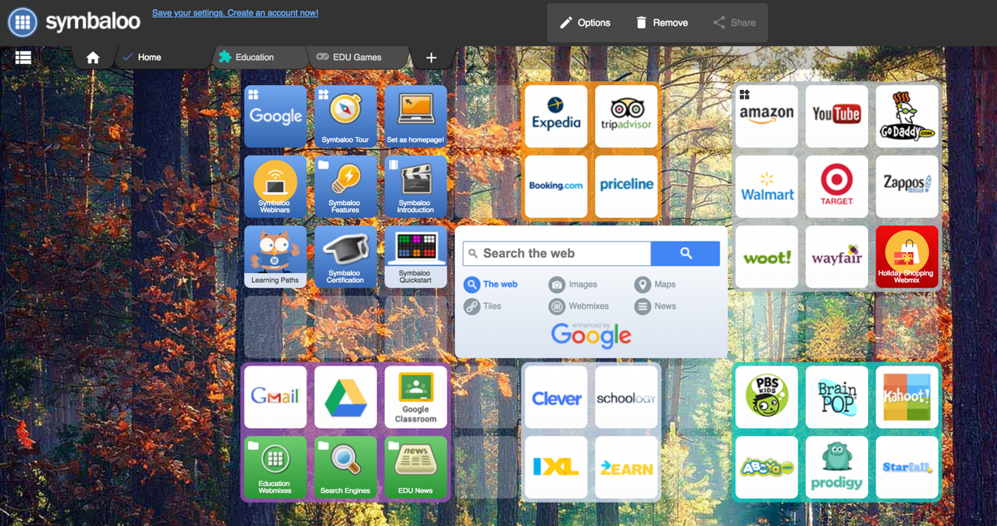

**Figure 3.** A Screenshot of a SymbalooEDU Home Page/Webmix

The second example, Pinterest, is popular in the commercial and blogging world. This platform is useful to the military because, like YouTube, is commonly used as a “how to” and Do It Yourself (DIY) site. Users can post links to other content across the web and add their own comments to orient others to the benefit of that specific resource. Figure 4 shows a screenshot of a user search within Pinterest. Each of the pictures in the screenshot is a linked resource and the colored boxes at the top of the figure are general categories.

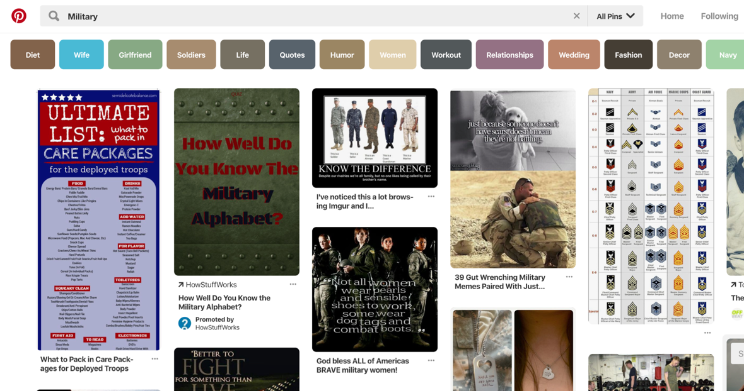

**Figure 4.** A User Search in Pinterest for “Military” Resources

A future human subject experiment is required to test the effectiveness of the current CEH™ compared to a solution that implements the proposed launch page. The experiment would be best conducted in a military context where up-to-date training and education resources were needed to accomplish an operational mission. The experiment would measure the amount of collaboration in each implementation and compare user contributions. Additionally, data analysis would be conducted on the number and size of user-created categories.

**8. Future Work**

Additional research is needed to test the effectiveness of SDL in the military context. Specifically, how does the military need to develop its educators and trainers to best leverage SDL? What traits make a good SDL instructor? Current research shows that a lack of SDL skills in a learner cannot usually be overcome by a tool, therefore learners may need to be taught the discipline of SDL at the beginning of their service or before being exposed to a tool. This reality could point to a niche for military instructors in teaching members *how* to learn using SDL tools where they perform their operational mission.

Furthermore, this research raises questions concerning the most appropriate time to give a warfighter the freedom to be a self-directed learner. What are the dangers of this and how do we continue to provide robust guides and mentors to explain the expectations without negatively impacting their learning?

**9. Conclusion**

The USAF is currently conducting a complete overhaul of its education and training paradigm shifting from multi-month face-to-face programs to a modular, agile, on-demand design. This initiative plans to leverage advanced learning and education tools to create and sustain life-long learners in the USAF. This is a lofty goal that can only be obtained by developing systems that leverage both people and technology to promote SDL. The concept of SDL can assist military educators to move members develop a heutagogical approach to learning, motivating members to apply themselves to learning throughout their military tenure. The USAF is at a unique time in history when technology is available to effectively and efficiently assemble education and training content to enable the development of large populations to help prepare them to adapt to the challenges ahead. The CEH™ is an emerging tool that already has great potential and could be improved by integrating elements of other effective PLEs. Specifically, the addition of a user-defined launch page would encourage more customization and provide another robust avenue for /collaboration. The CEH™ addresses the unique challenges of cyber education and training and has the potential to inform the design of future CoL systems both inside and outside the cyber domain.

**References**

Attwell, G. (2007) “Personal Learning Environments – The Future of eLearning?” *eLearning Papers*, 1 Vol 2, no 1, January, [www.elearningpapers.eu](http://www.elearningpapers.eu).

Blaschke, L. M. (2012) “Heutagogy and Lifelong Learning: A Review of Heutagogical Practice and Self

Determined Learning,” [online], *The International Review of Research in Open and Distance Learning*. <https://doi.org/10.1016/j.system.2004.09.015>.

Chiaramonte, M.V., Howe, D.R., Collins, J.A. (2016) “Air Force CyberWorx Report 16-001: A 21st Century Training Model for Flexible, Quick, and Life-long Workforce Development,” USAF Academy, CO: CyberWorx.

Eddins, J. M., Jr. "Byte-Size Learning." Airman Magazine. May 8, 2018. Accessed December 31, 2018. <http://airman.dodlive.mil/2018/05/08/bytesizelearning/>.

Harwood, C. (2011) “A Review of “SymbalooEDU, the Personal Learning Environment Platform.” ELTWorldOnline.com, Vol 3, March. <http://blog.nus.edu.sg/eltwo/2011/03/27/a-review-of-symbalooedu-the-personal-learning-environment-platform>.

Hase, Stewart, and Chris Kenyon, eds. (2013) *Self-determined learning: Heutagogy in action*, A&C Black.

Hase, Stewart, and Chris Kenyon (2000) "From Andragogy to Heutagogy," *Ulti-BASE In-Site*.

Haworth, R. (2016) “Personal Learning Environments: A Solution for Self-Directed Learners,” [online], *TechTrends* 60 (4): 359–64. <https://doi.org/10.1007/s11528-016-0074-z>.

Hiemstra, R. (2011) "Self-Directed Learning: Individualizing Instruction–Most Still Do It Wrong," *International Journal of Self-Directed Learning* 8, no. 1, pp 46-59.

Knowles, M. S. (1975) *Self-Directed Learning: A Guide for Learners and Teachers*. Oxford, England: Association Press.

Mattis, J. (2017) “Secretary of Defense Jim Mattis’ House Armed Services Committee Written Statement for the Record,” [online], [http://www.politico.com/f/?id=0000015c-9f04-d0 70-a57d-fffe4c600001](James%20Mattis,%20).

Reith, M., Trias, E., Dacus, C., Martin, S., and Tomcho, L. (2018) "Rethinking USAF Cyber Education and Training," Proceedings of the 13th International Conference on Cyber Warfare and Security, pp 439-447.

Reith, M. (2016) “Forging Tomorrow’s Air, Space, and Cyber War Fighters: Recommendations for Integration and Development,” *Air & Space Power Journal*, Winter, Vol 30, No. 4, pp 96-107.

Roberson, D.L., Stafford, M.C. (2017) “The Redesigned Air Force Continuum of Learning: Rethinking Force Development for the Future,” Air University Press, Curtis E. LeMay Center for Doctrine Development and Education.

Tomcho, L., Reith, M. (2018) “Engaging Airmen with Cyber Education and Training.” *Journal of The Colloquium for Information System Security Education*, Winter.

Tomcho, L., Lin, A., Reith, M., Long, D., Coggins, D. (2018). “Applying Game Elements of Cyber eLearning: An Experimental Design.” Air Force Institute of Technology.

Yannakogeorgos, P., Geis, J. (2016) *The Human Side of Cyber: Organizing, Training, and Equipping the Air Force*, Cyber Workforce. Maxwell AFB, AL: Air University Press.